Diane Arndt

Brother Gedeborg

WDD 330

November 12, 2022

Block 2 Challenge Proposal

* 1. Purpose – To show the time zone for any specific area entered by the user.
  2. Audience – Any one who needing to know the time zone of any specific area.
  3. Data sources
     + External API – The two sites I have looked at are:

<http://worldtimeapi.org>

<https://www.timeapi.io/>

* + - localStorage - I believe I should be able to take advantage of localStorge for this app.
  1. Initial Module list –

Index.html

Style.css

Main.js

* 1. Wireframes for each view of your application

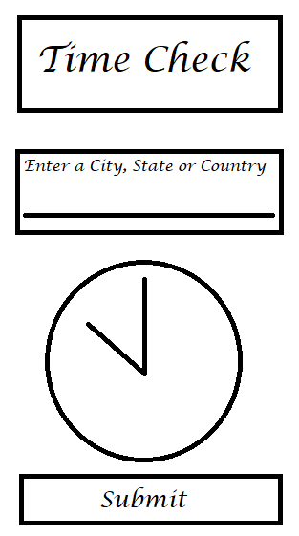

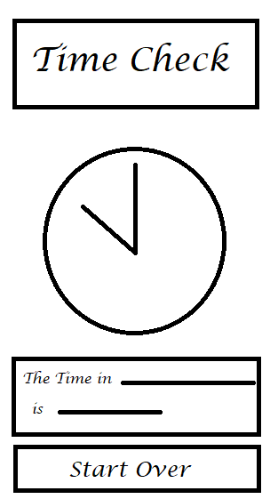

* 1. Colors/Typography/specific Element styling



Body – B7BABC – gray

Header – C1D9EC – light blue

Lucida Calligraphy – Colors FFFFFF and 3A8ECF, white and blue

Clock face – FFAE41

Clock Hands - black

* 1. Schedule to provide yourself mile markers along the way to help you stay on target.

Week 10 – Work on HTML and begin JavaScript

Week 11 & 12 – Work on JavaScript

Week 13 – Work on CSS styling

Week 14 – Finish up any final adjustments.